Communications – quarterly report – October to December 2014

Purpose of report

To outline communications activity between October and December 2014.

Summary

Since December 2012, and following the publication of our communications plan and strategy, a monitoring and evaluation system has been developed to allow tracking and recording media coverage. As well as volume of media activity, it also allows the tone of coverage (positive or negative) and ratio of proactive and reactive coverage to be measured.

The main results for October to December 2014 are:

- National media mentions up 54 per cent year-on-year from 253 in the same period for 2013 to 391 in 2014.

- 76 per cent of coverage was through pro-active media work against our target of 75 per cent.

- 83 per cent of our national coverage was positive.

- More than 330,000 website page views by nearly 220,000 unique users.

- 256 mentions of the LGA in Parliament from October to December.

Recommendation

That the Leadership Board notes the communications activity for the period October to December 2014.

Action

None.

Contact officer: David Holdstock

Position: Director of Communications

Phone no: 020 7664 3056

E-mail: David.holdstock@local.gov.uk

Communications – quarterly report – October to December 2014

Background

- Our three year Communications Strategy sets out our key targets, which includes a target to deliver high quality communications activity which is 75 per cent proactive, with a clear focus to national media.

- Our aim is to position ourselves as the ‘come to’ organisation on all matters which affect local government through high quality, proactive communications. When it is necessary to react to events, stories or announcements, we will ensure the LGA provides a strong voice for local government, defending the sector’s position.

Media activity – October to December 2014

- Our strategy has been to focus more on national media coverage to ensure maximum coverage for the key issues for local government. The following sets out all media coverage for the period October to December 2014.

Quarterly media coverage

 | October – December 2014 | October – December 2013 | October – December 2012
Coverage (all) | 8521 | 6563 | 4971
National (Print, online, broadcast) | 391 | 253 | 127

- This quarter has seen another rise in national media coverage year-on-year. This has been driven by sustained media activity around our 100 Days campaign and proactive work around NCAS, the Autumn Statement and Local Government Finance Settlement.

Year-to-date

 | March to December 2014 | March to December 2013 | March to December 2012
Coverage (all) | 14936 | 12345 | 10976
National (Print, online, broadcast) | 1269 | 947 | 363

- All of our media coverage increased by 20 per cent year-on-year to date with national coverage up 34 per cent during the same period.

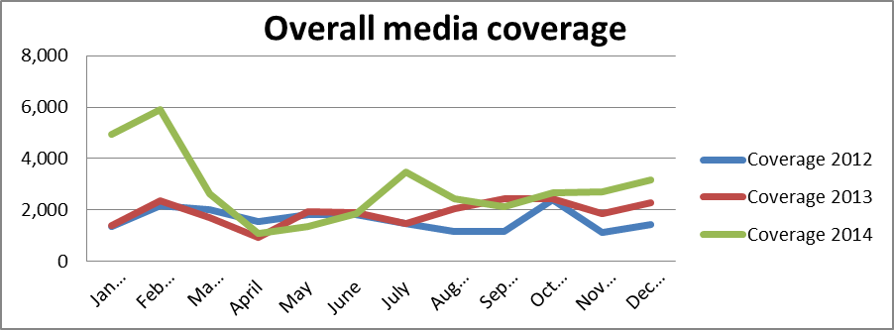

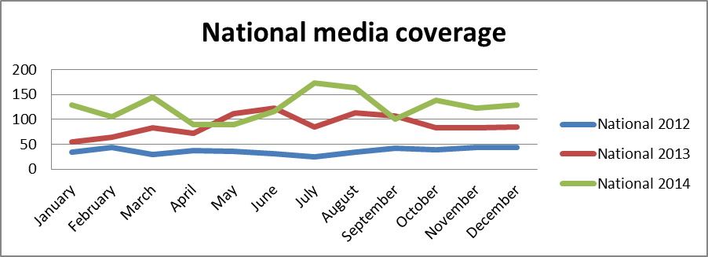

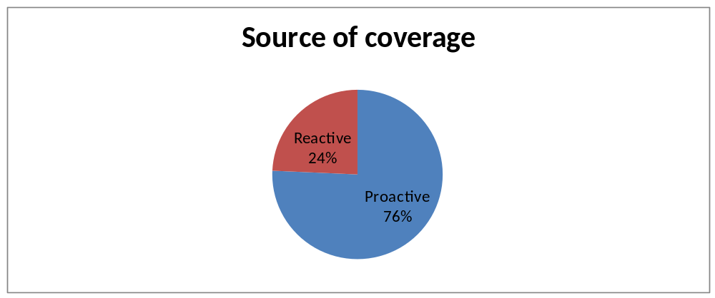

- 76 per cent of media coverage this quarter was through pro-active work, down from 88 per cent in the previous quarter (July-September 2014). This is due to our work on rebutting a number of negative stories on topics ranging from parking charges, the use of B&B accommodation to house vulnerable care leavers and streetlights being switched off.

- Our pro-active work has focussed on 100 Days, devolution, term-time school holidays, youth unemployment, social care funding and our calls for a review of Ofsted. As a result, 83 per cent of our coverage this quarter was positive.

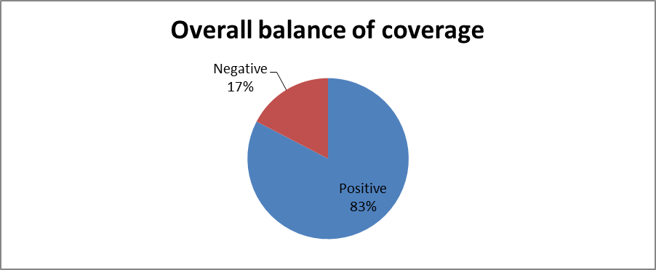

- Proactive releases this quarter included:

  - Our response to Autumn Statement/Local Government Finance Settlement (47 episodes of media coverage)
  - Our call for common sense approach to term-time holidays (44 episodes of media coverage)
  - Our call on behalf of fire authorities for safety messages to be displayed on e-cigarette chargers (16 episodes of media coverage)
  - Our call for an urgent review of Ofsted (13 episodes of media coverage)
  - Chewing gum manufacturers urged to pay for clean-up of streets (12 episodes of media coverage)
  - Winter readiness - Councils ready for the Big Freeze (11 episodes of media coverage)
  - Our response to the National Audit Office report on Better Care Fund (5 episodes of media coverage)

- Millions of veterans need access to vital council support (5 episodes of media coverage)

Print and online media

- The following sets out national newspaper and online coverage for the period October to December 2014.

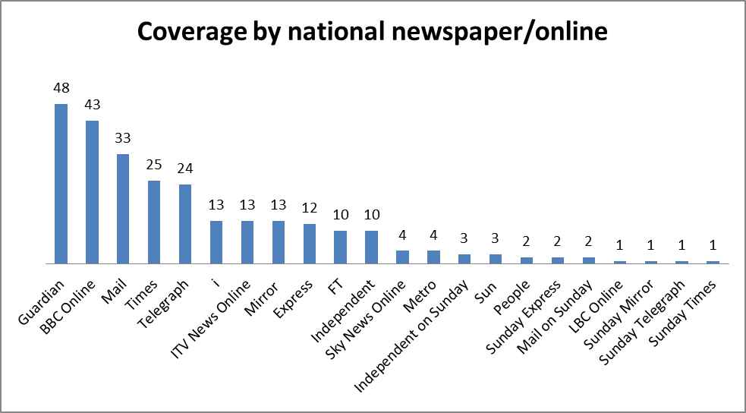
- The LGA appeared in 22 daily and Sunday titles during this quarter. We featured in the Guardian most with 48 mentions while BBC Online (48 mentions) and the Mail (33 mentions) covered a wide range of stories including devolution and social care funding.

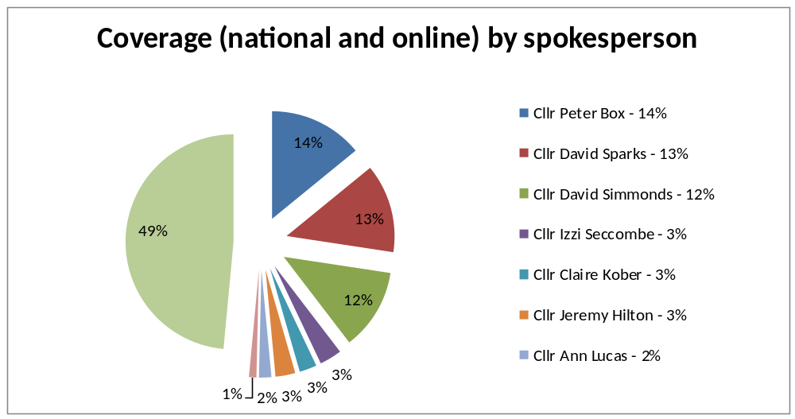

Broadcast media

- The following sets out our broadcast activity for the period October to December 2014.

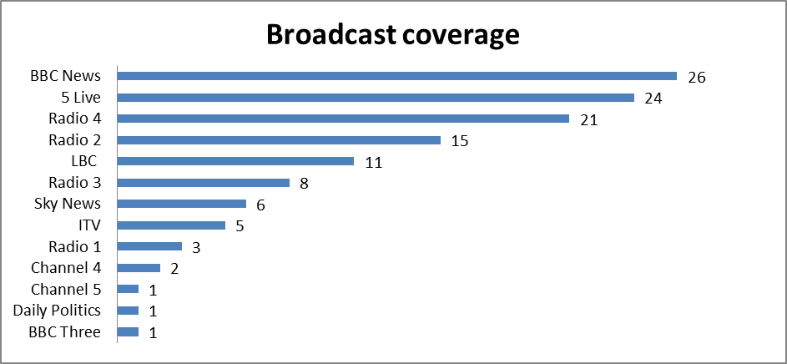

- Our media work saw 124 episodes of media coverage on national TV and radio this quarter.

- Cllr David Sparks appeared live on BBC News in October as part of rolling coverage of a Parliamentary debate on devolution following the Scottish referendum.

- Ahead of the Provisional Local Government Finance Settlement, Vice-Chairmen Cllr Gary Porter appeared on BBC Daily Politics and Cllr Gerald Vernon Jackson on BBC One O’ Clock News and Cllr Peter Fleming was interviewed on BBC Radio 2. Cllr Sparks responded to the announcement live on BBC News, Sky News and BBC Radio 5 Live.

- Cllr David Simmonds was interviewed on Radio 4’s Today Programme, Sky News and BBC News about our call for a more common-sense approach to term-time holidays.

- Our call for chewing gum manufacturers to help fund council clean-up bills was discussed by Cllr Peter Fleming on BBC Radio 4’s PM programme and BBC Radio 5 Live on November 22. This led directly to the CLG Select Committee’ calling in’ a number of senior industry figures to give evidence.

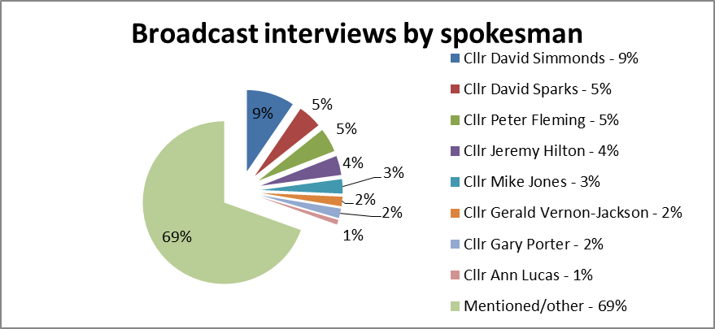

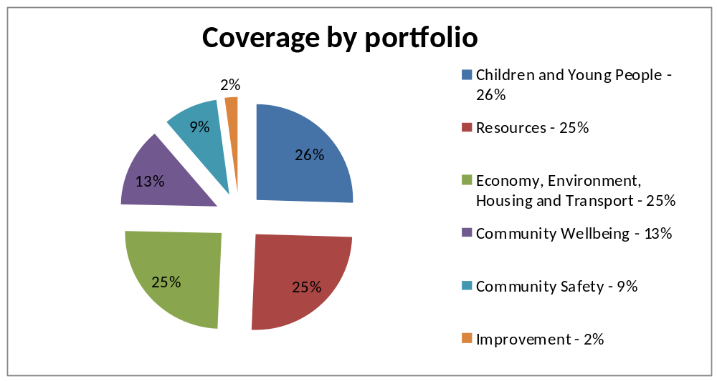

- The vast majority of coverage this quarter was positive.

- Negative Children and Young People coverage came from calls for a review of council child protection procedures and FOI figures on the cost to councils of using taxis to transport children to and from school, while in Community Wellbeing it was on criticism from charity Mind on council mental health spending, cuts to meals on wheels services and independent living assistance.

- In Economy and Transport, it was on the turning off or dimming of streetlights, delays in the production of local plans, a lack of housing for vulnerable residents and parking income.

- Negative Finance stories included council reserves and unpaid council tax. In Community Safety, it was on cuts to trading standards budgets.

- In Improvement, stories reporting the new Transparency Code and a perceived lack of transparency from councils on their parking profits generated negative coverage.

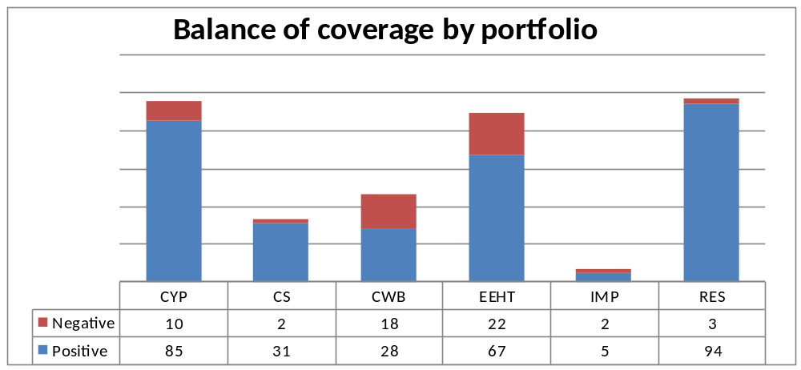

Campaigns and public affairs activity, October - December 2014

Summary

- The LGA was referenced 256 times in Parliament between October and December. During this time Parliament met for 86 sitting days which means that on average we were mentioned three times each day Parliament was sitting.

- During this period a number of key pieces of legislation were debated in Parliament, including the Serious Crime Bill, the Infrastructure Bill, the Deregulation Bill and the Small Business, Enterprise and Employment Bill.

- Senior LGA representatives gave evidence to parliamentary inquiries being held by the Political and Constitutional Reform Committee, the Public Accounts Committee, the Health Committee and the Affordable Childcare Committee.

Legislation

- Since the last report, we have been working to promote and develop our proposals for the Serious Crime Bill, the Infrastructure Bill, the Deregulation Bill and the Small Business, Enterprise and Employment Bill.

- The Serious Crime Bill had its Report Stage in the House of Lords in October and its Second Reading in the House of Commons in January. Having previously secured an amendment to the Bill to ensure that the offence of participating in the activities of an organised crime group did not capture unwitting local authorities, we have since focused our lobbying efforts on highlighting local government’s concerns with individuals encouraging or promoting Female Genital Mutilation (FGM). Crossbench Peer Baroness Meacher led a proposed LGA amendment which sought to make it an offence for a community or religious leader to encourage the practice of FGM. Whilst the Government opposed this amendment in the House of Lords, they are now considering whether such a safeguard could be introduced in the House of Commons. We are also working with Dexter Dias QC, a human rights barrister with a special interest in tackling FGM, to develop our proposed amendment. The Government has also informed Parliament that a specialist FGM unit akin to the Forced Marriage Unit will be created.

- The Deregulation Bill received its House of Lords Committee Stages during October and November, where Peers scrutinised the detail of the Bill. We supported the tabling of amendments and briefed Peers throughout the Committee Stage, and the key highlights were:

  - In a lobbying success for the LGA, the Government withdrew Clause 10 of the Bill which had proposed to allow anyone to drive an off-duty private hire vehicle. This was of major concern to our member councils.

  - We supported amendments and receive cross-party support opposing the Government’s proposal to ban the use of CCTV in parking enforcement. We succeeded in getting the Government to accept that certain exemptions were necessary for bus lanes, bus stops, red routes and around schools.

  - We supported a series of amendments that would have allowed councils to have greater powers on house building and on right-to buy sales. LGA President Lord Best led the amendments on the right-to buy would mean councils setting their own discount levels, based on local markets and localising decision-making, allowing more investment by councils’ in the building of much needed houses. He also led an amendment on our proposition for removal of the housing borrowing cap.

  - On licensing, LGA Vice President Baroness Smith of Basildon (Labour) moved amendments which have led to some progress on our call for government to conduct a wholescale review of licensing and seek to improve the process for ancillary sales of alcohol.

- The Infrastructure Bill - Our position on the clauses relating to the proposed reforms of the Highways Agency, the Land Registry, planning, the transfer of public sector land to the Homes and Community Agency and the establishment of development corporations by councils were all referenced by MPs during the Second Reading debate. Since the Second Reading we have supported MPs in tabling amendments to the Bill to be considered at Committee Stage which sought to change the composition of the new Strategic Road Companies so as to ensure that local government is represented at the highest level of decision-making, obligate the Secretary of State to provide a report on the effect on local authorities of the proposed Land Registry reforms, extend the proposals on land transfers to allow publicly owned assets to be transferred to local authorities in order to support housing development, and introduce a statutory community benefit scheme for fracking. We also called for the Infrastructure Bill to be amended to reform the approach to the implementation of Sustainable Drainage Systems (SuDS).

- The Small Business, Enterprise and Employment Bill - We briefed MPs ahead of the debate, seeking clarification from the Government that it does not intend to use the powers in the Bill to centralise procurement, which will not work for local government and small businesses who are interested in providing goods and services within their localities. While we welcomed moves to ensure public money is spent in a clear and accountable way, we highlighted our concerns that the provisions in the Bill on public sector exit payments could have unforeseen and unfair consequences. The Committee Stages of the Bill take place in January 2015 and we are working with Peers to secure the addition of a new Clause to the Bill to ensure that the procurement proposals do not interfere with the innovative work of councils in procuring goods and services.

Parliamentary select committees

- Senior LGA representatives gave evidence to a selection of parliamentary inquiries. Chair Cllr Sparks gave evidence to the Communities and Local Government Committee on the subject of ‘Councillors on the frontline', highlighting our ‘Be A Councillor’ campaign. He also used the session to set out the wide-ranging responsibilities undertaken by council leaders and volume of work.

- Cllr Sparks gave evidence to the Political and Constitutional Reform Committee on the future of devolution, during which he made the case for devolution to communities through councils and highlighted our ready-made plan for devolution set out in our 100 days report.

- Cllr Liz Green, Deputy Chair of the Children and Young People’s Board, gave oral evidence to the House of Lords Affordable Childcare Committee. She reiterated our call for an analysis of funding costs led by councils and providers on the basis of which a sufficient funding level could be set and gave examples of councils taking action to make childcare more accessible, affordable and of a higher quality.

- Cllr David Simmonds, Chair of the CYP Board, and Carolyn Downs, our Chief Executive gave evidence to the Communities and Local Government Committee on the Jay report into child sexual abuse in Rotherham. Their evidence covered the work of the Rotherham Improvement Board in dealing with governance and working with the council on member-officer relations, on what good governance looks like and providing support and challenge to the council’s financial plan. We also provided support to Rotherham Council in advance of their evidence sessions with both the Home Affairs and Communities and Local Government committees.

- Carolyn Downs, our Chief Executive also gave evidence to the Health Committee and the Public Account Committee. These technical hearings were an opportunity to highlight our concerns on the future of health and social care and the Better Care Fund and to call for 5 year funding settlements and for social care funding to be protected in the post-election Comprehensive Spending Review.

- We provided formal written evidence to inquiries held by the Political and Constitutional Reform Committee into The Future of devolution after the referendum, the Education Committee inquiries into Apprenticeships and traineeships for 16 to 19 year olds and careers advise, the Communities and Local Government inquiry into litter and the Health Committee inquiry into public expenditure in health and social care and the impact of physical activity and diet on health.

Further briefing activity and parliamentary debates

- We briefed for a variety of parliamentary debates, including discussion on the future of devolution following the Scottish referendum, economic leadership to cities, housing and planning, fracking, social and physical activity and public health.

- Cllr Sparks met with a number of senior politicians to discuss amongst other issues financial sustainability and the Autumn Statement, health and social care and devolution. This included meetings with the Chief Secretary to the Treasury Danny Alexander MP, the Leader of the House of Commons William Hague MP, the Minister for Government Policy Oliver Letwin MP, the Leader of the Opposition Ed Miliband MP and the Shadow Chancellor of the Exchequer Ed Balls MP.

Support to our membership

- We continue to support councils working on public affairs issues with our Parliamentary Network and weekly parliamentary bulletin. In addition to this we worked with the Programmes Directorate to produce On the Day briefings for our membership on the Smith Commission, the Autumn Statement and the Local Government Finance Settlement.

100 Days campaign

- ‘Investing in our nation’s future: the first 100 days’ has continued to gain traction with Ministers, Shadow Ministers, members, council officers and stakeholders.

- To date, the document has been downloaded 5,565 times and 4,000 hard copies have been distributed to members, at events and at the party conferences. The accompanying film has been viewed more than 1,100 times.

- Members also increasingly using the localised infographic tool, with over 1,000 page views this quarter.

- 100 Days has generated 123 episodes of national media coverage across 16 publications and 9 different broadcast channels and programmes.

- An ongoing stakeholder engagement programme has been running as part of the 100 days campaign. To date 30 stakeholders have submitted their views, timed with campaign and Parliamentary activity, these have included:

Action for Children | National Trust
Alcohol Concern | RAC Foundation
Asphalt Industry Alliance | Ramblers
CentreForum | RSPCA
Centrepoint | RTPI
CILT | Scope
CLGF | St Mungo’s Broadway
FMB | The Children’s Society
Guide Dogs | The Kennel Club
Home Builders Federation | The Kings Fund
Joseph Rowntree Foundation | Trading Standards Institute
Living Streets | UK Health Forum
Localis | Universities UK
NatCen | Water UK
National Federation of Builders | Woodland Trust

- The campaign microsite, developed to host all content relating to the campaign, has had 7,159 page views and 2,880 unique visitors during the last quarter and 24,781 page views and 7,523 unique visitors since July.

Improvement - #OurDay

- For the third year running, we held #OurDay on Wednesday 26 November. The day is an opportunity to showcase the breadth of work that councils do throughout a typical day on Twitter and other social media platforms. This year, in response to councils, we produced a toolkit which was downloaded 2,935 times.

- A total of 16,564 tweets were sent during the day (up from 11,000 in 2013) from council staff, members and chief executives. The tweets had a potential reach of 397 million users. The hashtag #OurDay was the second and third most popular topic in the UK for most of the 24 hours.

Digital Communications

- On average, more than 23,000 people visit www.local.gov.uk every week. During the period October 2014 - December 2014, local.gov.uk had 336,095 visits (+18 per cent on Q2) from 219,923 (+20 per cent on Q2) unique users.

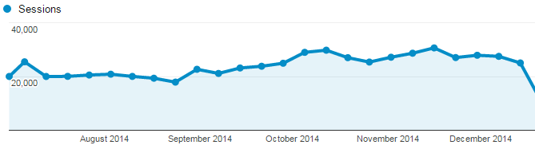

- Once on the site, the average user visits 3.43 pages of our website.

- The most popular content of our website is our publications section followed by our homepage and the care and support reform implementation page.

- The audiences for our two corporate twitter feeds (@LGAComms and @LGANews) have continue to grow this quarter, with @LGAComms reaching 10,000 followers at the end of December. Currently, a total of 13,486 accounts follow the two corporate accounts.

- The growth in our audience has also driven an increase in the potential number of people we’re reaching with each tweet. This quarter saw our tweets reach a potential audience of 12.5 million people (+26 per cent on Q2).
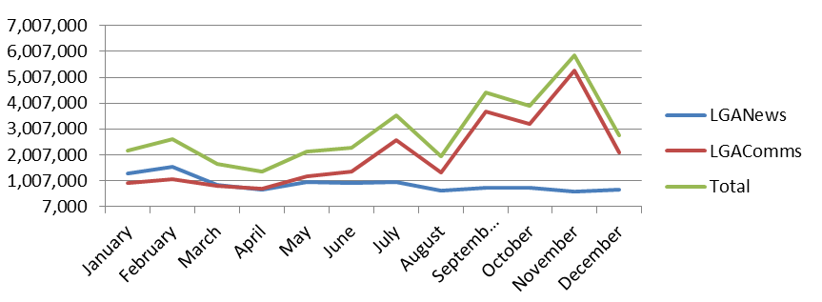
- Subscriber numbers for programme bulletins have increased across all bulletins in the last quarter with the exception of Improvement and Innovation and Workforce which saw small decreases. We also launched a new Cities and Regions bulletin to reflect the new board structure.

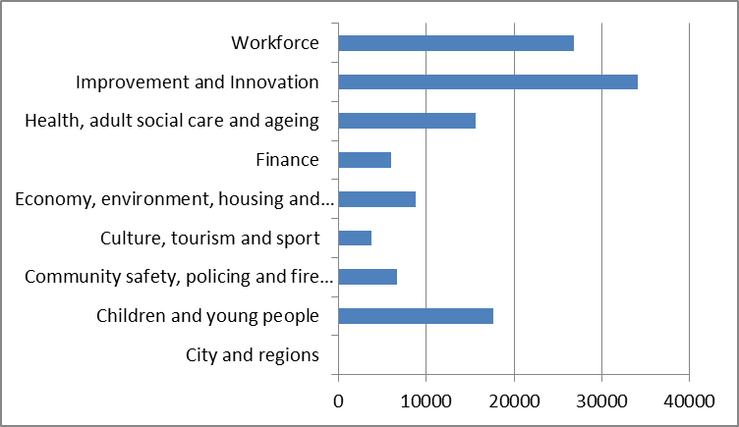

- Cllr Sparks’ bulletin, which is sent to leaders and group leaders every Saturday morning, has seen an increase in click rates.

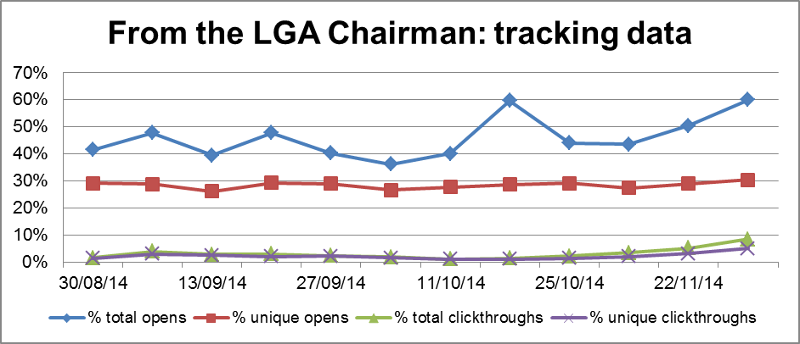

N.B. Total opens appears higher than unique opens when emails have been opened a number of times either by the original recipient or when the emails have been forwarded on.

- This quarter has seen an increase in the open rates for the Chief Executive’s bulletin – sent out to chief executives of member councils. There has also been an increase in this email being forwarded on.

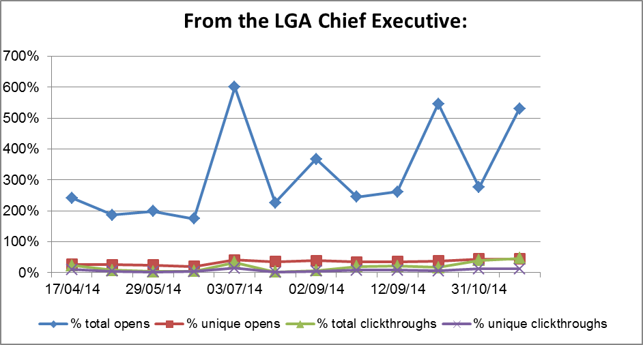

N.B. Total opens appears higher than unique opens when emails have been opened a number of times either by the original recipient or when the emails have been forwarded on.

